OVLP/SRP Academic Year 2025-26
Duration: April 20 - 24, 2026 |  | Grade: Pre-Nursery |  | Subjects: All
Term III |  |  | Week: 8
 | English | Urdu |  | Math | IT | HCD
Links | class story  The Dark Forest The Little Firefly  https://drive.google.com/file/d/1L9pUorlMogVSLUpbl2MxG3qFKdzqsfCA/view?usp=sharing  The Kind Farmer and the Clever Cow  https://drive.google.com/file/d/1PjpGDXqaMBzFycjlhqpkM_y4mYPm-Kwf/view?usp=sharing  Letter x  https://drive.google.com/file/d/1enufGiZ05XYeFXxfS7WRoM3mMUlLaBNO/view?usp=share_link  Reading Letter x  https://drive.google.com/file/d/1BYaPNim_5_mEHhB6fbobyCyFAe2h1sIT/view?usp=sharing | Class story  Murghi or chiriya  https://drive.google.com/file/d/1l1Gdko6TYpm5cb6e8JHlenTX2PK9_s5h/view?usp=sharing  Bhalu ka bacha  https://drive.google.com/file/d/1ncUv2pL3RmwAOLrY5lHQ84rCgscjfDzj/view?usp=sharing  Ont or Saya  https://drive.google.com/file/d/1kickcOMQo0xpV-bJFEhDATb68gkuEENC/view?usp=sharing  harf zohen.  https://drive.google.com/file/d/1fwhXggXHwSiiKTPCgqplIEOPeNW1zZjY/view?usp=share_link  Reading harf zohen.  https://drive.google.com/file/d/1374-lfp8GwKiQB5RAmH6fwvpH6sAvGgN/view?usp=sharing |  | Number 23.  https://drive.google.com/file/d/1oD3EYWJDPP3RThdJjPMY_sZ1YLPwHDf1/view?usp=share_link | Week 8 OVLP Grade Pre-Nursery IT Term 3.mp4 | P.N TIIISRP8
Day 1  C.W | - Writing “x”.  - Draw a picture with “x”. (xylophone or Xmas-tree)  - Note book pg. # 24 | 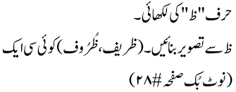 |  | Recognition of number 23 |  | Pupils will learn about Kindness and courtesy/We need eyes to see
Home work | - Writing “x”.  - Draw a picture with “x”. (xylophone or Xmas-tree)  Note book pg. # 25 |  |  |  | -------------- | ---------------
Day 2  C.W | Reading letter x | 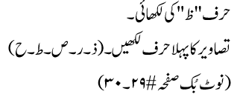 |  | - Write number 23.  - Tracing and overwrite 1st letter of the shape. (triangle)  - Note book pg. # 21 |  | Pupils will learn about the food of the week is Melon
Home work |  | 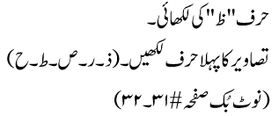 |  |  | ---------------- | ----------------
Day 3 | - Writing “x”.  - What comes next?  s ______ , q______ ,  v______ , u______ , l__________  Note book pg. # 26 | 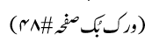 |  | - Write number 23.  - Join the dots to make triangle shape and write 1st letter.  Note book pg. #22 |  | Revise the any previous games
Home work |  |  |  | - Write number 23.  - Join the dots to make triangle shape and write 1st letter.  Note book pg. # 23 | --------------- | -----------
Day 4  C.W | - Write a-x.  - Match the same letters (t – x).  - Note book pg. # 27-28 | 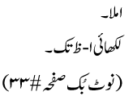 |  | Workbook pg. # (68). |  | Oral Questions.  Q.1: What is the national language of Pakistan? Ans: Urdu is the national language of Pakistan..1: Which Dua do we say when we go downstairs. Ans: We say “SUBHAN ALLAH” when we go downstairs. Q.1: How do you see the things? We see things with our eyes.
Home work |  |  |  |  |  | ----------------
Day 5  C.W | - Dictation.  - Write m-x.  - Note book pg. # 29 | پڑھائی حرف ظ |  | - Dictation.  - What comes next?  - Write the first letter of shapes. (Star, triangle)  Note book pg. # 24 | Revision of all week’s work. | The revision of all the previous work done this week is complete.
Home work |  | Reinforcement  OGA will be taken on Monday |  |  |  | --------------

